TPJC 2009 H1 Chemistry Prelim Paper -Suggested Solutions
Paper 1_MCQ
1 | C | 2 | D | 3 | A | 4 | A | 5 | B | 6 | D | 7 | C | 8 | B | 9 | B | 10 | D
11 | C | 12 | C | 13 | D | 14 | D | 15 | C | 16 | A | 17 | C | 18 | C | 19 | D or B | 20 | B
21 | C | 22 | A | 23 | B | 24 | C | 25 | B | 26 | C | 27 | A | 28 | D | 29 | D | 30 | A

Paper 2_Section A
Suggested Answers
Ethandioate ions, C₂O₄²⁻, are oxidized to carbon dioxide by 0.020 moldm⁻³ acidified aqueous potassium manganate (VII), KMnO₄.
C₂O₄²⁻ → 2CO₂ + 2e⁻
- Using relevant half equations from the databooklet and the one above, write down the overall balanced equation for this redox process. [1]
MnO₄⁻ + 8H⁺ + 5e → Mn²⁺ + 4H₂O -------(1) x 2
C₂O₄²⁻ → 2CO₂ + 2e ----(2) x5
2MnO₄⁻ + 16H⁺ + 5C₂O₄²⁻ → 2Mn²⁺ + 8H₂O + 10CO₂

(b) Calculate the number of moles of ethandioate ions present in 0.22g of the salt, KHC₂O₄∙H₂C₂O_{4.} [Mr of salt = 218.1] [2]
moles of salt = 0.22/218.1 = 1.01 x10⁻³ mol
moles of ethandioate ions = 2 x 1.01 x10⁻³ = 2.02x10⁻³ mol

(c) Hence, calculate the volume of KMnO₄ required to oxidize 0.22g of KHC₂O₄∙H₂C₂O₄ completely? [2]
5C₂O₄²⁻ ≡ 2MnO₄⁻
moles of MnO₄⁻ = 2.02x 10⁻³ x 2/5 = 8.08 x 10⁻⁴mol
Volume of KmnO₄ required = 8.08 x 10⁻⁴ / 0.02 = 0.0404 dm³
= 40.4cm³
Question 2 [6 marks]
A distinct trend is observed in the 1st ionization energies of elements in the same period.
(a) Define by means of an equation (including state symbols) what is meant
by the term 1st ionization energy of sodium metal. [1]

Na (g) → Na⁺ (g) + e

(b) State and explain the trend of the 1st ionization energies across the period sodium to argon.
Across the period, [2]
- The no of protons increases, hence nuclear charge increases
- The no of electron shells remain the same, hence screening/ shielding effect remains the same
- The effective nuclear charge increases
- More energy is required to remove a mol of electron from the element
- Hence, 1st IE increases across the period
- The graph below shows the variation in ionization energies for the outermost 8 electrons in an atom of the element X.
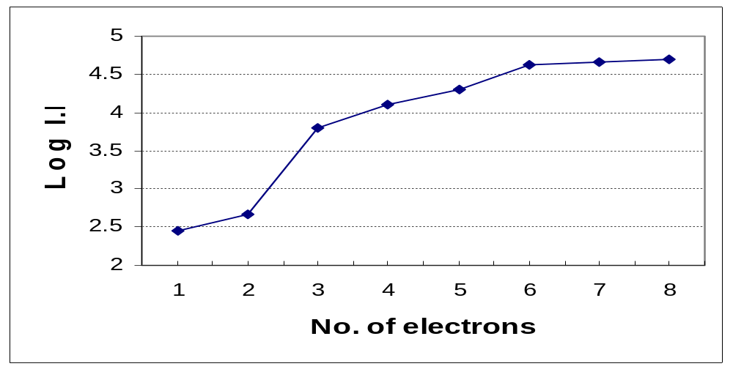
State, giving reasons, to which group element X belongs to? [2]
- Element X belongs to group II
- Reason: There is the largest energy difference between the 2nd electron to be removed and the 3rd electron
- Hence, 3rd electron must be from the next inner shell and there are 2 valence electrons.

(d) Hence, draw a dot-and-cross diagram for the compound formed between chlorine and element X. [1]

x x
x

x x
x x
[ x ]²⁺ 2[ Cl ]⁻

Question 3 [7 marks]
Aqueous solution of chrominum (VI) ion exists in equilibrium in 2 different forms as shown below.
2CrO₄²⁻ (aq) + 2H⁺ (aq) 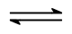 Cr₂O₇²⁻ (aq) + H₂O(l)
yellow orange
(a) Define Le Chatelier’s Principle [1]

Le Chatelier’s Principle states that if a system in equilibrium is subjected to a change (disturbance), the equilibrium position shifts so as to minimise the effect of the change.
Or
Le Chateleir’s Principle states that if a change is made to a system in equilibrium, the system reacts in such a way as to tend to oppose the change, and a new equilibrium is formed.

(b) Explain the effect and state any color change when a small amount of NaOH(aq) is added to the equilibrium mixture. [2]

When a small amount of NaOH is added, it reacts with the H⁺ ions
reducing the concentration of H⁺ ions in the system.
According to LCP, equilibrium will shift to the left to produce more H⁺
Colour observed is yellow.

- An experiment was carried out with initial values of 0.4 mol CrO₄²⁻ (aq), and 0.3 mol of HCl (aq) in a 1 dm³ reaction vessel.
After some time, equilibrium of CrO₄²⁻ (aq) and Cr₂O₇²⁻(aq) was established at a fixed temperature. It was found that 62.5% of the
CrO₄²⁻ (aq) had reacted.
(i) Write down the K_{c} expression for this equilibrium system. [1]
K_{c}
=
[Cr₂O₇²⁻]
[CrO₄²⁻]²
[H⁺]²

(ii) Calculate the value for the equilibrium constant, K_{c}, at the fixed temperature. State the units of K_{c.} [3]
Amt of CrO₄²⁻ that had reacted = 0.4 x 0.625 = 0.25 mol

2CrO₄²⁻ (aq) + 2H⁺ (aq) Cr₂O₇²⁻ (aq) + H₂O(l)
I 0.400 0.300 - -
C -0.25 -0.25 +0.125
E 0.15 0.05 0.125

K_{c}
=
0.125
0.15² x 0.05²

= 2.22 x 10³ mol⁻³ dm⁹

Question 4 [5 marks]
In oil refineries, an important process is the recovery of any sulfur from petroleum. Sulfur compounds are converted into the gas hydrogen sulfide, H₂S, by using a catalyst. The H₂S is then oxidised by using a controlled amount of air to give steam, H₂O(g) and sulfur, S(s).
(a) Define the term standard enthalpy change of formation. [1]
Standard enthalpy change of formation of a compound is defined as the enthalpy change when 1mole of the compound is formed from its constituent elements under standard conditions at (298K,1 atm).

(b) Given the enthalpy change of formation of H₂S(g) is -20.5 kJ mol⁻¹ and that of water is -243.0 kJmol⁻¹, calculate the enthalpy change of the oxidation of hydrogen sulfide, H₂S(g). [2]
H₂S(g) + 1/2O₂ (g) → H₂O (g) + S(s)
∆H_{r} = -243.0 – (-20.5) = -222.5 = -223 kJ mol⁻¹

(c) Another important by-product from an oil refinery is hydrogen gas as shown in the equation below.
CH₄(g) + 2H₂O(g) CO₂(g) + 4H₂(g)
Given that the enthalpy change of combustion of CH₄(g)= -890kJmol⁻¹, information from (b) and the energy cycle below, calculate the enthalpy change of the reaction of methane and steam. [2]
CH₄(g) + 2H₂O(g) CO₂(g) + 4H₂(g)
+ 2O₂ (g)
(-243 x 4)

+ 2O₂ (g)
(-890)

CO₂ (g) + 4H₂O (g)

Enthalpy of Formation of 1 mol of H₂O = enthalpy of combustion of 1 mol of H₂
∆H_{c} (H₂) = -243 kJmol⁻¹
∆H_{r} + (4 x -243) = -890
∆H_{r} = +82 kJ mol⁻¹

Question 5 [9 marks]
Some data of Group VII hydrides are shown in the table below.
 | HF | HCl | HBr | HI
Boiling point/ ⁰C | +20 | -85 | -67 | -35
Bond energy/ kJmol⁻¹ | 562 | 431 | 366 | 299

(a)(i) Explain why the boiling points of HCl, HBr and HI increases down the Group as shown in the table above. [2]
-Electron cloud/ atomic size of Cl < Br < I or size of halogen atom increases down the group
- The larger the electron cloud size (or atomic size) of halogen, the greater the id-id forces between the HX molecules
-Hence, more energy is required to overcome the intermolecular forces of HI molecules, followed by HBr and lastly HCl.
-Hence, HI has the highest bp, followed by HBr and lastly HCl.

(ii) Explain why the bond energy of HF, HCl, HBr and HI decreases down the Group as shown in the table above. [2]
-Electron cloud/ Mr/ no. of electrons of F< Cl < Br < I increases down the group
-There is less effective orbital overlap between H atom and the halogen atom moving down the group
or bondlength of HX increases down the group
-Therefore, less energy is required to break the bond of H and X atoms, moving down the group.
-Hence, bond energy decreases down the group.
- Draw a diagram showing the main intermolecular forces present in HF.
[1]
H^{∂+}- F^{∂-}
XX
lllllllllllllll
H^{∂+}- F^{∂-}
Hydrogen bonding

(b) The table below shows the melting points of some oxides of elements shown below.
 | Melting Point/ ºC
Carbon dioxide, CO₂ (s) | -78
Sodium oxide, Na₂O (s) | 1132
Magnesium oxide, MgO(s) | 2852

- Explain, in terms of structure and bonding, the difference in the melting points of CO₂(s) and Na₂O(s). [2]
  - CO₂ has a simple molecular structure with weak id-id forces between the molecules.
  - Na₂O has a giant ionic structure with strong ionic bond between oppositely charge ions.
  - Since, more energy is required to overcome the strong ionic bond in Na₂O as compared to weak id-id forces between CO₂ molecules,
  - Bp of Na₂O is higher than that of CO_{2.}

- Explain, in terms of structure and bonding, the difference in the melting points of the Na₂O(s) and MgO(s). [2]
  - Both Na₂O and MgO have giant ionic lattices
  - 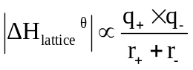Difference in ionic bond strength depends on the charge density of the cations in Na₂O and MgO.
- Lattice energy,

- Since, the charge of Mg²⁺ is greater than Na⁺, the ionic bond strength is greater for MgO than Na₂O
- Thus, more energy required to break ionic bond of MgO than NaO

Question 6 [8 marks]
Compound A is a constituent of peppermint oil.
A reaction sequence diagram starting with compound A is shown below.
(a) Draw the structural formula of the compounds D, F, G and H in the spaces provided. [4]
CH₃
O
A
CH₃
OH
B
CH₃
O
C

CH₃
COOH

E
OH
G
F
D
H
Br₂ (l), in CCl₄
CH₃COOH
Conc. H₂SO₄
Na (s)
NaCN/ H₂SO₄ (aq)
10-20⁰C
Step I
Step II
Heat
CH₃
Br
Br
CH₃
OOC-CH₃
CH₃
OH
CN
CH₃
O⁻Na⁺
COO⁻Na⁺

(b) Give the reagents and conditions for step I and Step II. [2]

(i) Step I : H₂(g), Ni (s) / LiAlH₄ in dry ether
(ii) Step II: Acidified K₂Cr₂O₇ , reflux or acidified KMnO₄, reflux

(c) Describe a simple chemical test, stating reagents, conditions and observations to distinguish compound B from C. [2]
Test: Acidified K₂Cr₂O_{7,} reflux or Acidified KMnO₄, reflux
Observation: Colour change from orange to green or purple to colourless for B but no colour change for C
Or
Test: 2,4 DNPH, warm
Observation: Orange ppt produced for C but no colour change for B
Or
Test: PCl₅
Observation: White fumes of HCl for alcohol, B but no fumes evolved for C.

---End of Section A---

Section B-Suggested Answers

1a) The order of reaction with respect to a given reactant is the power to which the concentration of the reactant is raised in the experimentally determined rate equation.

The half-life of a reaction is the time taken for the concentration of the reactant to be reduced to half its initial concentration.

b) (i) From Expt 2 & 3 : Order of reaction wrt Y is 2.
From Expt 1 & 2 : Order of reaction wrt X is 0.
(ii) rate = k [Y]²
k = rate/ [Y]²
= (4.0 x 10⁻⁴) / (0.2)²
= 1.0 x 10⁻⁶ mol⁻¹dm³s⁻¹
(iii)
Graph:
fraction of
total molecules
T1
T2
Ea
kinetic energy
T2 > T1
Ea = activation energy

Explanation:
- fraction of molecules with energy E ≥ Ea increases at higher than T.
- frequency of effective collisions increase.
- hence the rate of reaction increases.

(c) (i) No of moles of CO2 formed =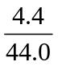 = 0.10 mol
No of moles of C = 0.1 mol

• No of moles of H2O =1.80/18.0 = 0.10 mol

No of moles of H atoms = 2x 0.010 = 0.20 mol

•0.025 mol of X contains 0.10 mol of C and 0.20 mol of H.
=> 1 mol of X contains 4 mol of C and 8 mol of H.

Thus, molecular formula of X is C4H8.

(ii)

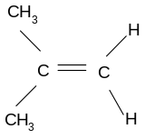 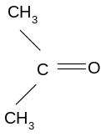 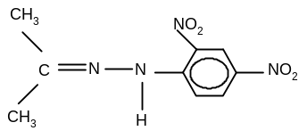 X Y Z

(iii) • X contains a terminal C=C bond so it produces CO2 (g)/ X undergoes
oxidative cleavage.
- Y is a methyl ketone so forms yellow ppt. in the iodoform test

• Z is formed when carbonyl group in Y reacts with 2,4,-DNPH

8 (i) pH = - log [H+]
[H⁺] = 10 ^{– 2.11}
= 7.76 x 10⁻³ mol dm⁻³

(ii) No. of moles NaOH used = (33.3/1000 x 0.150) mol
No. of moles citric acid titrated = (33.3/1000 x 0.150) mol
[citric acid] = (33.3/1000 x 0.150)/ 20.0 x 10⁻³ mol dm⁻³
[H⁺] = (33.3/1000 x 0.150)/ 20.0 x 10⁻³ mol dm⁻³
= 0.248 mol dm⁻³

(iii) In part (i) [H+] is a measure of the free hydrogen ions obtained when the acid dissociates.
In part (ii) [H+] is a measure of the total concentration of hydrogen ions present in the acid.

(iv) Phenolphthalein, the working range pH of the indicator is within the pH at equivalence point.

- Ka = [citrate ion] [H+]
[citric acid]

(vi)
I. C5H7O4COOH + OH– → C5H7O4COO– + H2O
The added OH – ,combines with the citric acid to form citrate ion and water so change in pH is resisted.

II. C5H7O4COO– + H⁺ → C5H7O4COOH
The added acid, H⁺, combines with the citrate ion to form the weak acid. Thus change in pH due to the addition of small amount of acid is resisted.

(b) (i) carboxylic acid, ester,(tertiary) alcohol, ketone (or carbonyl group) (ii) Oxidation of alcohol (secondary)
H+/Cr2O7²⁻; warm
For compound B: Orange solution turns green
For compound A : No colour change

Or
Test for ketone
2,4-DNPH; warm
For compound A : orange ppt
For compound B no ppt.

(i) MgCl2 , SiCl4
(ii) MgCl2
- Giant ionic structure
- Strong electrostatic forces between Mg²⁺ and Cl⁻ ions
- Lots of energy needed to break strong electrostatic forces
So m.pt of Mg Cl2 is high.
SiCl4
- Simple covalent molecular structure
- Weak van der Waals forces between SiCl4 molecules
- Little energy needed to break the weak intermolecular forces
- So m.pt of SiCl4 is low.
(iii) MgCl2
- Soluble in water
- MgCl2 (aq) → Mg²⁺ (aq) + 2 Cl⁻ (aq)
pH of solution formed 6.5 (due to partial hydrolysis of Mg²⁺ (aq) ions)

SiCl4
- soluble in water
- SiCl4 (l) + 2 H2O(l) → SiO2 (s) + 4HCl(aq)
- pH of solution formed 2 (due to formation of strong acid HCl)

9 (a) (i) Heat evolved when 1 mole of substance is completely burnt in oxygen
under standard conditions (298K, 1 atm)
(ii) CH₃CH₂OH + 3 O₂ → 2CO₂ + 3H₂O
(iii) Heat gained by water = heat lost by ethanol
mc ∆T = no of moles ethanol used x ∆H_{c}(ethanol)
100x 4.18 x (25.0-18.5) = 56.56 – 56.46 x ∆H_{c}(ethanol)
M_{r} of ethanol

∆H_{c}(ethanol) = - (100 x 4.18 x 6.5) / (0.10/46.0)
= - 1249.8
= - 1250 kJ mol-1 (to 3 s.f.)

(iv) All the heat given off by the combustion of ethanol is gained by the water in the calorimeter.

(v)

Bonds Broken | Bond energy | kJ mol⁻¹ | Bonds Formed | Bond energy | kJ mol⁻¹
5 C-H bonds | 5 x 410 = | +2050 | 4 C=O | 4 x 740= | - 2960
1 C-C bond |  | + 350 | 6 O-H | 6 x 460= | - 2760
1 O-H bond |  | + 460
3 O=O bonds | 3 x 496= | +1488
1 C-O bond |  | + 360
 |  | + 4708 |  |  | - 5720

Theoretical ∆Hc(ethanol) = + 4708 – 5720 = -1012 kJ mol⁻¹

(vi) A precise bond enthalpy for a particular chemical bond depends to some extent on the environment in the molecule where the bond exists, that is, it depends on what other atoms are attached to the two atoms of the bond to be broken.
Bond energy values refer to average values so the theoretically calculated value is less accurate

(b)(i)
- Br2(g) in the presence of uv light or sunlight
- free-radical substitution
- Br2(g) or Br2 (l) in the presence of AlBr3 (or FeBr3) catalyst
- electrophilic substitution

(ii)

E 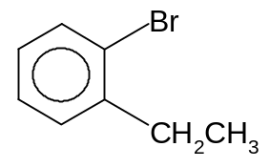 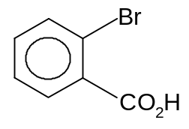X

(iii)
F
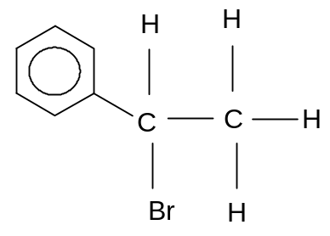

(iv) Elimination
(v) - yellow ppt (of tri-iodomethane)
- C containing the -OH group on G is attached to a CH3 group
and it also has an H attached to it
(vi) - H contains carbonyl group( or H is a ketone)
- H is not an aldehyde group

--------End of Section B--------

